Faculty Guide

# **Reporting Course Assessment Data Each Semester**

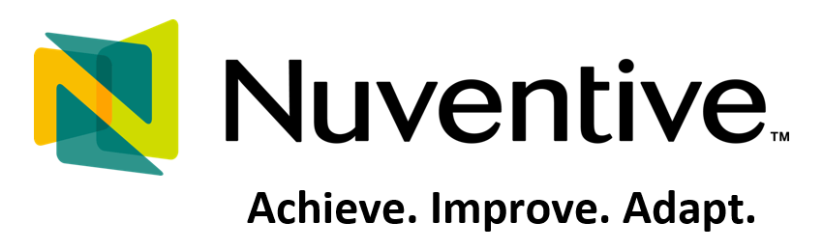

# **A step-by-step screenshot guide to entering**

# **course assessment data in Nuventive**

1. Log in to Nuventive at the new URL: <https://solutions.nuventive.com/>
2. Click on “Sign In” at the top right corner:

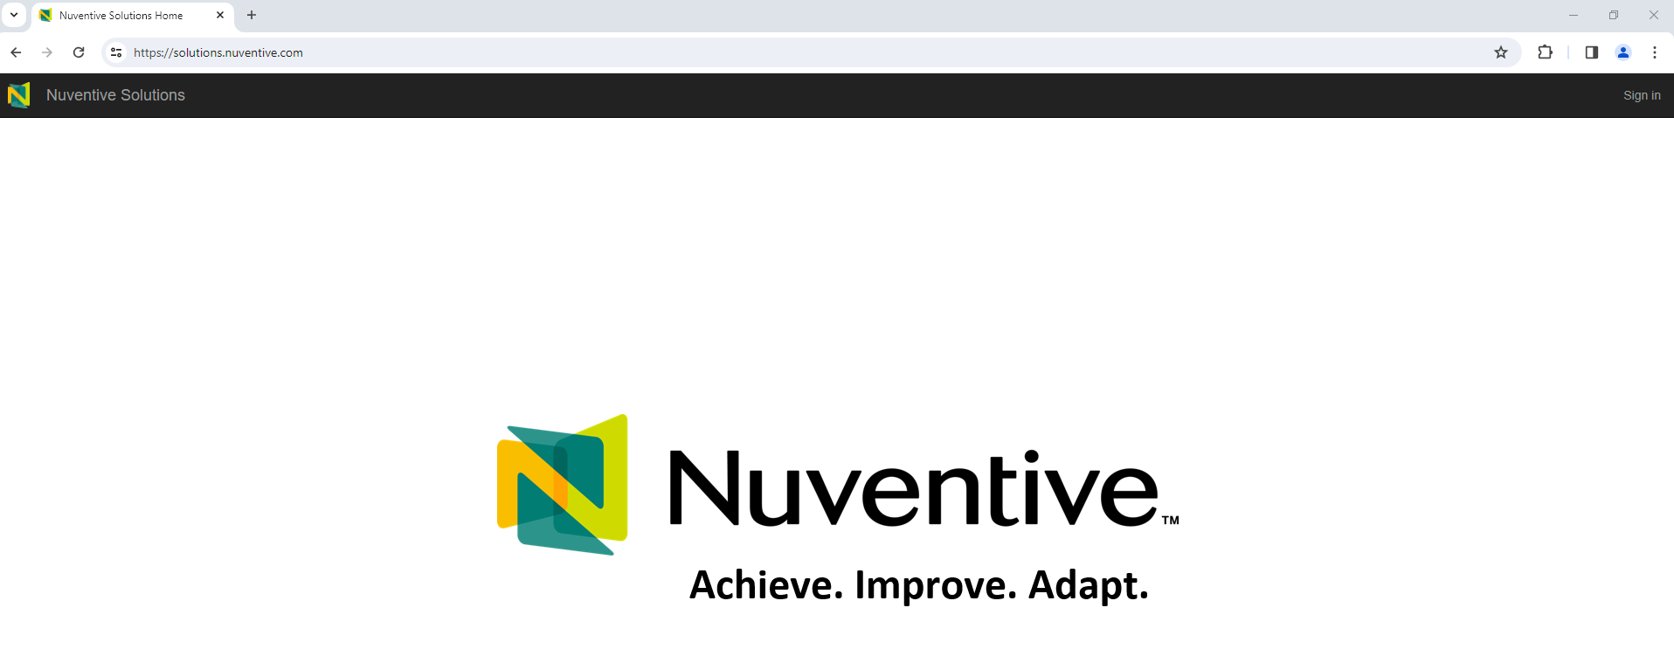

1. Nuventive is on LSSU’s Single Sign On system. If working from on campus, you will see the following screen and can simply click on your LSSU account to log in. (You will need to use the university VPN if working off-campus).

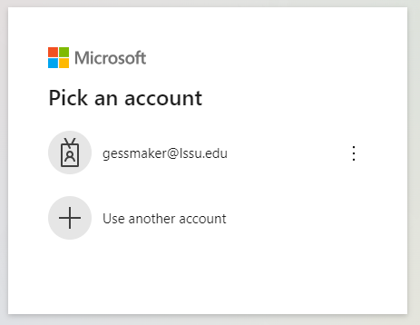

1. From the top drop down, scroll to **“TheCourses”** units at the bottom and click on your School unit:

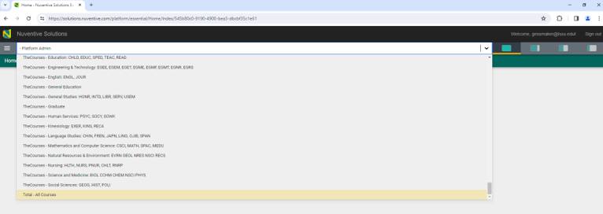

1. You can scroll through the list of courses under the center area labeled “Courses” (this is the long way to get there), or just click on the menu icon at the top left of your screen to open the drop down and select *Course Assessment* and then *Course Assessment Plans and Results.*

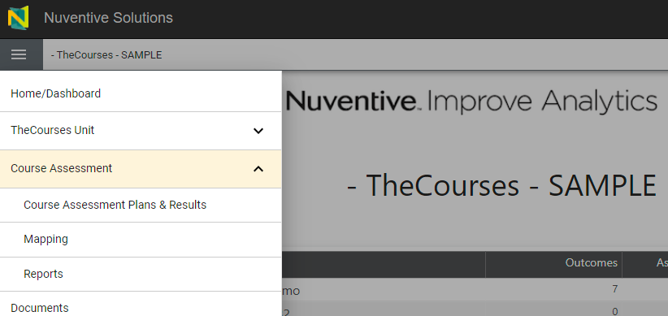

**3**

**2**

**1**

1. The main menu link will take you to the course where you entered data the last time you were logged in. To select any course in the unit, use the drop down for “Select a Course at the top right of the screen:

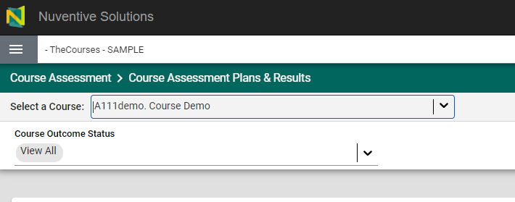

1. If the outcomes were previously entered for the course (in the old platform or in the new one), you will see the list of course learning outcomes.

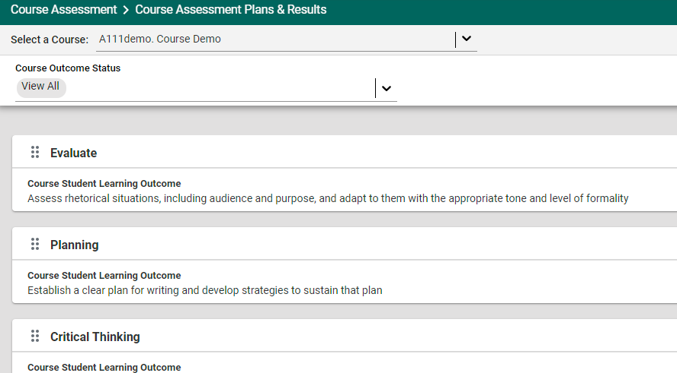

1. Double-click on an outcome to edit it, or to enter new data for that outcome. The outcome will open as shown:

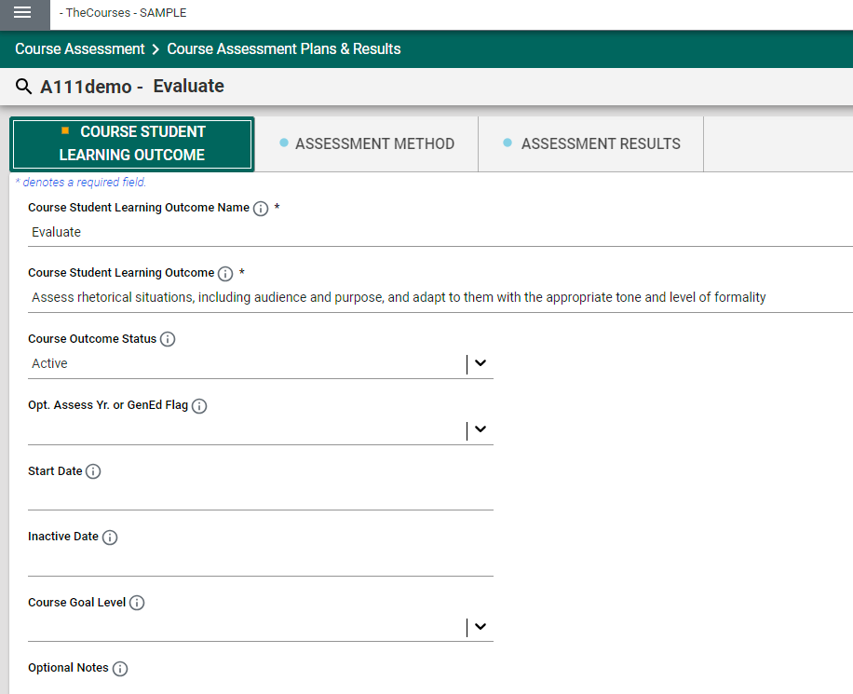

*Suggested:*

* The outcome name should reflect an appropriate Bloom’s taxonomy category.
* The outcome must be measurable through at least one specific course assignment or task.
* Set the outcome as active if you are assessing it this semester; if not, set it as inactive.
* Include additional information in the remaining areas if possible to make the reports as robust as possible; this will be useful in the Annual Assessment Update meetings each fall.
* **Click SAVE (or Close) when finished:**

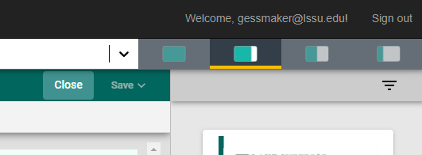

1. Click on the top tab for “Assessment Method” to review the assessment methods for each semester. If they have changed at all, update the assessment methods by double-clicking on that method to open it. If you are using a new assessment method, click on the “+” symbol at the top right of the screen to add that method:

Click on “+” to add a new assessment method

Double-Click method to open for review or to edit

Open the Assessment Methods tab

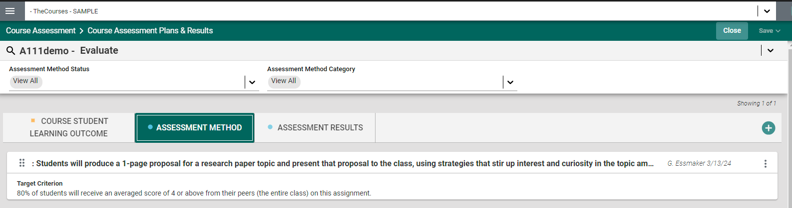

1. On the Assessment Method screen, you should list the method as Active or Inactive (inactive methods will not show up on the reports run from Nuventive). In the *Assessment Criteria and Procedure* area:

* clearly explain the task or assignment you are using to evaluate and measure students’ learning for the stated objective. A method could be a test, group assignment, individual assignment, project, paper, presentation, etc.
* explain how the task or assignment will be scored.

In the *Target Criterion* area, set a Target that you consider reasonable as the percentage of students you expect to achieve a specified level of learning (score, grade, etc.)

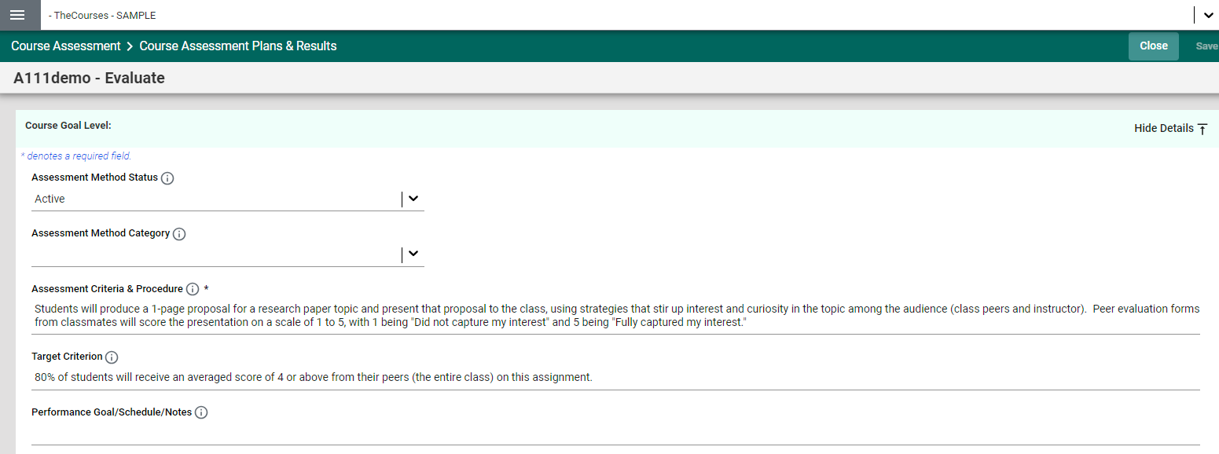

Fill in other areas if possible; this will make the reports as robust as possible for the Annual Assessment Update meetings each fall.

**Click SAVE (or Close) when finished:**



1. To enter your assessment results / data for the current semester or year, click on *Assessment Results* in the top toolbar.
2. To enter new assessment data / results for the current semester / year, click on the “+” symbol at the top right:

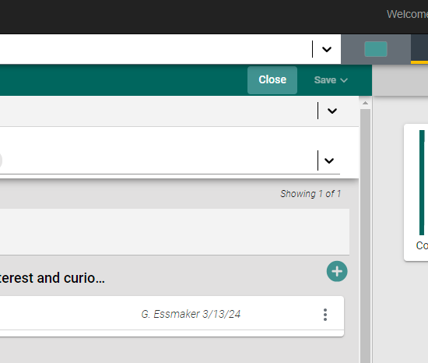

1. Enter your new results. Provide as much data as possible, and state whether the target goal was me / not met. An unmet goal is not a “fail.” It just gives more opportunity for a strong improvement plan under the *Use of Results* section. Once again, fill in as many areas as possible to ensure robust reports to be downloaded for the Annual Assessment Update meetings each fall.

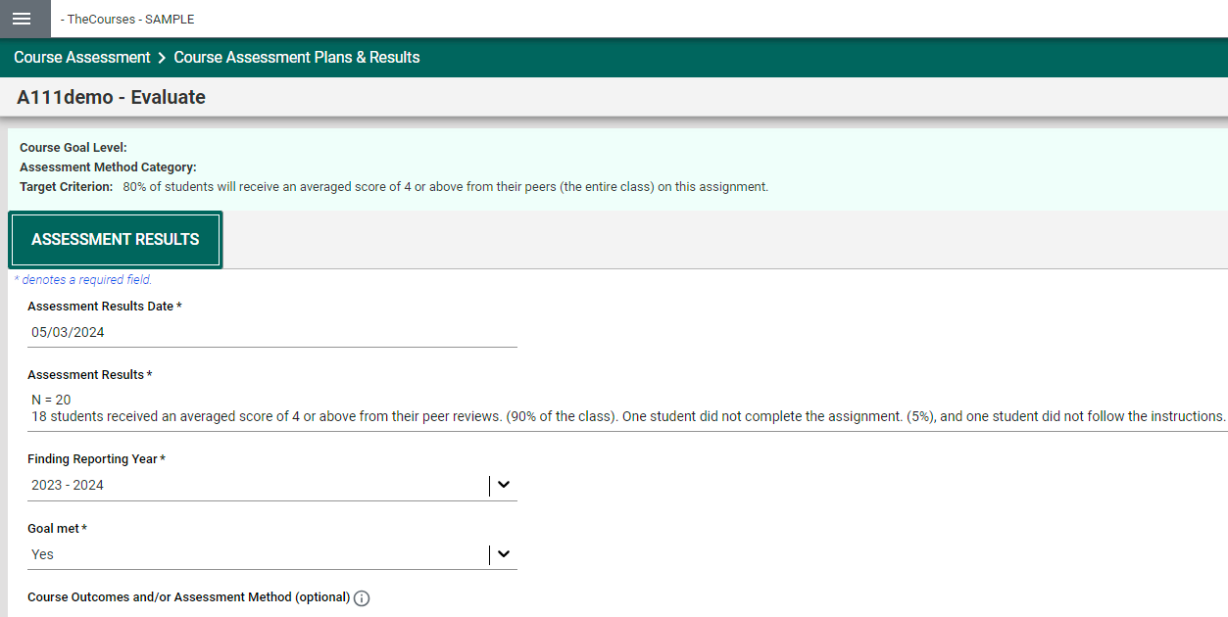

1. Scroll down the page to find the *Use of Results* section and enter your continuous improvement plan.

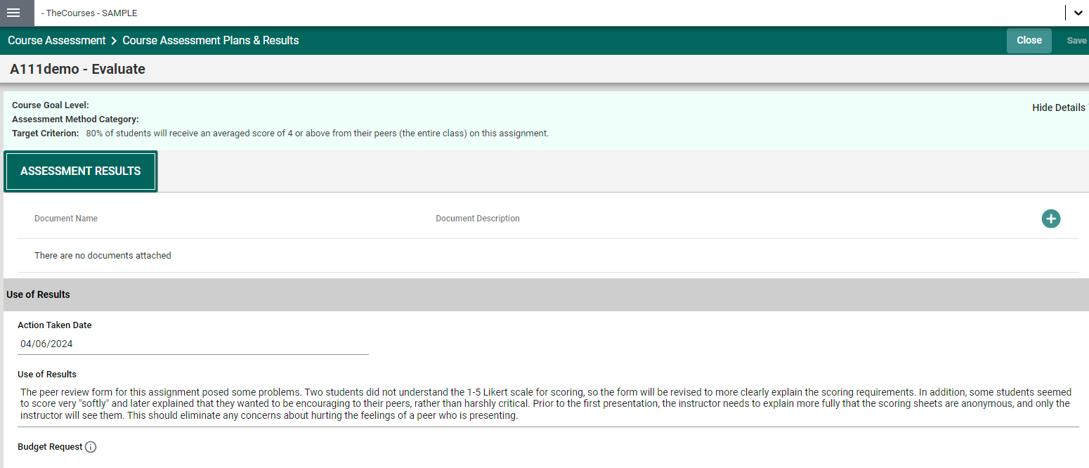

The goal of this section is to demonstrate a commitment to continuous improvement that facilitates student learning and achievement. This section should first evaluate the effectiveness of the assessment method, and then present a plan to improve student learning and performance. Even if student achievement was excellent for this outcome, there is always some room for improvement. For example, could students learn even more (or more effectively) if there were some group work engagement, or some study guides provided, more class discussion, additional examples provided, etc.

**Click SAVE (or Close) when finished:**



Once you have **closed** the *Assessment Results* editing screen, the system will return you to that main screen page. You can click on the *Course Student Learning Outcome* tab to return to the page listing the outcomes. Click on another outcome to begin the process again (see #8) and enter your assessment results for each of the course’s active learning outcomes.

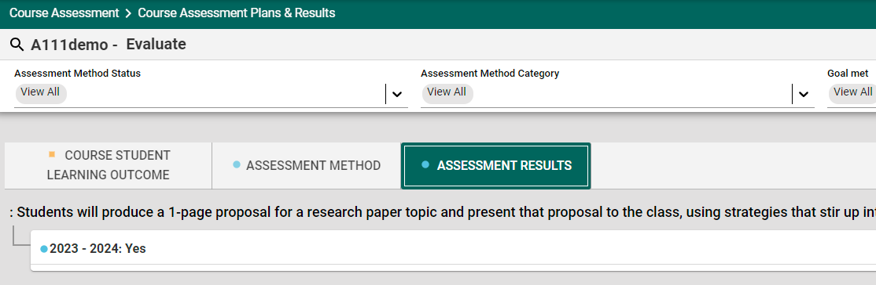

If you need assistance or if you would like some help setting up outcomes, assessment methods, or reporting results,, please contact:

Gail Essmaker

Vice Provost for Accreditation and Assessment

gessmaker@lssu.edu

906-635-2278